
A Worldwide Vacuum Truck Dealer Network

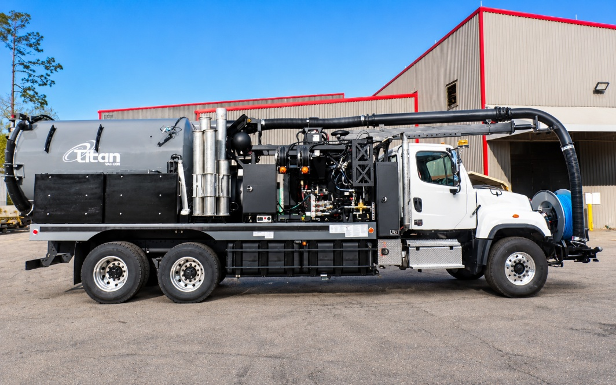
Chassis Specs:
Freightliner 114SD Plus 6x4 66000GVWR ISL370 3000 RDS

Estimated Hours: 190
Estimated Aux Hours: 42
Estimated Miles: 4,650
DUAL ENGINE

MODEL #: TAQD312LHAG-P/1300

700 #: 700-10828
UT #: UT374
Serial #: 02249921

FEATURES:
- 50 gpm/ 3000 psi Giant 70000,GM 6.0 gas 157 HP with aux engine hydraulics
- 600' x 3/4" Cobra brand Jet Rodder Hose
- 50' Capacity Retractable Hand Gun Hose Reel
- Hydro Excavation Package
- Remote Control Wireless: Boom, Vacuum Breaker, Throttle & Debris body (include Hi-Dump, if applicable) Does not include remote cable pendant controls for boom or hi dump.
- Omnibus Precision Power System
- Lazy Susan Pipe Rack
T: 888-817-1757
SalesTeam@vac-con.com
969 Hall Park Road, Green Cove Springs, FL 32043
www.vac-con.com

