
A Worldwide Vacuum Truck Dealer Network

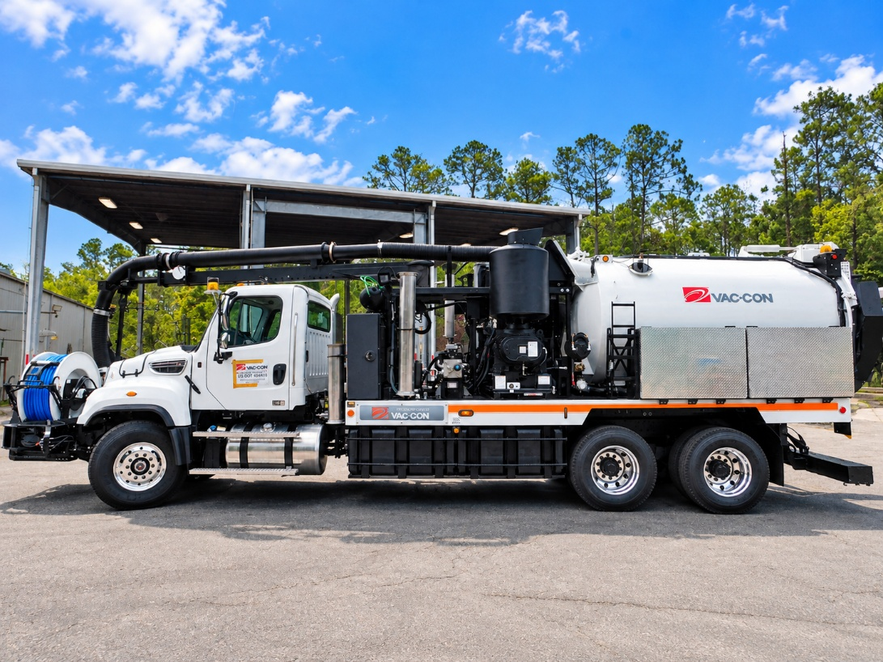
Chassis Specs:
Freightliner 114SD 6x4 66000 DD13

Estimate Hours: 3,100

Estimated Miles: 26,266
FEATURES:
- 80 gpm/ 3000 psi FMC water pump
- 500' x 1"-3000 PSI Piranha Jet Rodder Hose
- 10' Aluminum Telescoping Boom
- Front mounted hose reel , Articulating to driver side
- Enhanced Wireless Controls
- Water Recycling System, Includes recycling nozzle
- Remote Control Wireless: Boom, Vacuum Breaker, Throttle & Debris body (include Hi-Dump, if applicable) Does not include remote cable pendant controls for boom or hi dump.
- Omnibus Precision Power System -Electronic Controller System Includes: a color monitor, electronic footage counter, and pressure compensated hydraulics.
MODEL #:

VRPD3612LHAEN-P/1000

700 #: 700-10334
UT #: UT366
Serial #: 05229358

T: 888-817-1757
SalesTeam@vac-con.com
969 Hall Park Road, Green Cove Springs, FL 32043
www.vac-con.com

